


CHANGING THE STORY

OUR VISION
A regional Economy that creates wealth & shared prosperity for its communities

MISSION
Catalyse economic growth of Kenya’s coast regional counties

JUMUIYA YA KAUNTI ZA PWANI

www.jumuiya.org

Background of the Jumuiya ya Kaunti za Pwani (JKP)

Who are we?

The Jumuiya ya Kaunti za Pwani (JKP), also known as the Coast Region Economic Bloc, is a County Corporations Joint Venture established by the six Coastal County Governments of Kenya. Incorporated under the Companies Act, 2015, it serves as the region's primary economic development agency and investment facilitation vehicle.
Born from the spirit of devolution and inter-governmental cooperation, JKP has evolved from a collaborative secretariat into a dynamic corporate entity. This transformation grants JKP legal personality to enter contracts, own assets, and mobilize resources directly, enabling it to effectively implement the ambitious Jumuiya 2030 Economic Blueprint and drive integrated socio-economic transformation across the member counties.








Promotion
Policy
Investments
Coordination

Vision
A regional Economy that creates wealth & shared prosperity for its communities

Mission

Catalyze economic growth of Kenya’s coast regional counties

Our Mandate

Our Mandate: The Four Core Functions
- Coordination: Foster economic development cooperation among counties, national government, development partners, and the private sector.

- Policy Harmonization: Align County Integrated Development Plans (CIDPs), sectoral plans, and national blueprints with the Jumuiya 2030 strategy.

- Promotion: Market the region's unified investment, tourism, cultural, and heritage assets.

- Investment Facilitation: Develop and manage Public-Private Partnerships (PPPs) and flagship projects.

Background

The Jumuiya ya Kaunti za Pwani (JKP) is the Coastal Counties’ economic regional co-operation body that comprises the Mombasa, Kilifi, Kwale, Tana River, Lamu and Taita Taveta Counties. These six counties cover an area of 79,686 square Kilometers with a population of over 4 million people who share a common history, language, culture and infrastructure.
Jumuiya ya Kaunti za Pwani (JKP) is based on a triple helix model that brings together the six coastal regional counties, three local coastal Universities (Taita Taveta University, Pwani University and Technical University of Mombasa) and the private sector jointly collaborating in regional development goals. JKP was formed firstly by signing a memorandum of understanding between the universities and the six county governments on the 5th of January 2015. The objective of this memorandum was to encourage the collaboration and implementation of developmental, environmental, educational and economic policies for the region. In particular sharing the collective research and resources of the universities and working with the County Governments to build sustainable Governance structures that will work to transform the socio-economic well-beingof the people in the counties
Secondly a cooperation agreement was entered into on the 13th of June 2015 by between the Governments of the Counties of Kwale, Kilifi, Tana River, Lamu, Taita Taveta and Mombasa with the objective of the agreement according to article two of the cooperation agreement being, " The Parties being Counties of the coastal region of the aforementioned Republic, subject to the provisions of this Cooperation Agreement and the National and County laws, rules, regulations and policies from time to time in effect in the larger Republic aforementioned and in each County, mutually decide to strengthen, promote and develop co-operation in their developmental and socioeconomic agenda as well as fiscal, financial, and spatial planning in order to achieve expedited and sustainable development."
JKP achievements and highlights
Since its formation in 2015, the JKP has recorded a number of achievements which include but not limited to:
1.Agribusiness Food and Nutrition Strategy 2018-2030 - FAO
2. Health Systems Strategy AFYA 2018 -2025 – FAO
3. CIDP Harmonization – USAID – AHADI
4. Development of Harmonized County Investment Cooperations Framework
5. Jumuiya 2030 Economic Blueprint 2018 -2030
6. Jumuiya Blue Economy Strategy 2021-2030
7. 1 Million Acre Project - FAO
8. Jumuiya Innovation Lab – Generation Kenya, Ecobank, KCB Foundation, Regenesys
9. The Go Blue Project – 25Mil Euro – EU funded project
10. Blue Skies Vehicle Emission Project
11. The Jumuiya Agribusiness and Blue Economy Investment Conferences
(2018 -2024)
12. She Stands – Faith Based Initiative to empower women in the Coast region
13. Corona Crisis Mitigation strategy 2020 – AMREF
14. Global Health Security Summit – University of Nebraska
15. Africa Centre for Global Health Security – Africa CDC, Amref University
Implementation of the Jumuiya’s regional economic agenda is managed by the Governor’s Apex, the Sector Council, Six Sector Working Groups, and the Secretariat

Marking a decade of impact in 2025, JKP's journey represents a pivotal shift in regional development. From its foundational MoUs in 2015, through strategic blueprint development, to its current incorporation as a robust joint venture, JKP stands today as a testament to the power of collective action. This evolution positions the bloc to accelerate project implementation, attract larger-scale investments, and more effectively "Change the Story" of the Coastal region for the next decade and beyond.

JKP JOURNEY
JKP Journey: A Decade of Milestones

2015
- Signing of the foundational Memorandum of Understanding (MOU).
2017
- Development of the JKP 2030 Economic Blueprint.
2018
- Partnership with the Food and Agriculture Organization (FAO) established.
- First Jumuiya Agribusiness and Blue Economy Investment Conference (JABEIC) held in Mombasa.
2019-2020
- Launch of the 1 Million Acre Project with FAO.
- Development of the COVID-19 Recovery Strategy.
- Establishment of the Jumuiya Innovation Lab.
2021-2025
- Launch of the Go Blue Project (€25M EU-funded initiative).
- Launch of the Blue Skies Vehicle Emission Project.
- Launch of the She Stands women’s empowerment project.

2026-2030 (Forward Look)
- Go Blue Green Bond (Phase 2) – Future sustainable financing initiative.

JKP 2030

The Jumuiya 2030 Economic Blueprint is our region's master plan for inclusive and sustainable growth. It is operationalized through "The Jumuiya 10" – ten interconnected strategic sectors designed to build prosperous and resilient coastal communities.
The Jumuiya 10 Strategic Sectors:
- Agribusiness, Food Security & Nutrition
Building a resilient and productive agricultural value chain to ensure food sovereignty and improve livelihoods.

- Trade, Industry & Sector Development
Promoting value addition, industrialization, and market access to enhance regional competitiveness and trade.

- Blue Economy Sector Development
Sustainably harnessing marine and aquatic resources for economic growth, job creation, and environmental conservation.

- Natural Resources & Environmental Management
Ensuring sustainable utilization, protection, and restoration of the region’s natural capital and ecosystems.

- Urbanization & Spatial Development
Planning and managing urban growth to create livable, resilient, and economically vibrant coastal cities and towns.

- Health, Education, Water & Sanitation
Investing in human capital through improved healthcare, education systems, and universal access to clean water and sanitation.

- Infrastructure Sector Enabler
Developing robust physical and digital infrastructure—transport, energy, ICT—to connect communities and drive economic activity.

- Land Resource Banking & Management
Optimizing the use and governance of land as a critical asset for development, investment, and social equity.

- Jumuiya Investment Fund & Financial Mobilization
Establishing innovative financing mechanisms and attracting investment for regional flagship projects and PPPs.
- Governance Foundation & Enabler
Strengthening institutions, policy harmonization, peace, and security to provide a stable foundation for sustainable development.

This multi-sectoral approach ensures integrated development, where progress in one pillar catalyzes growth in another, maximizing impact for the people of the coast.

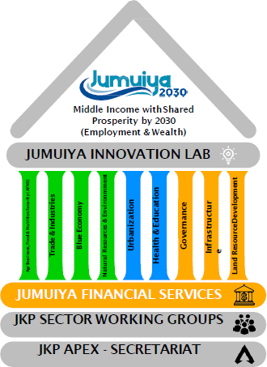
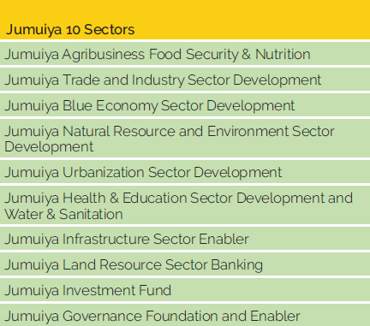

JKP PAST AND CURRENT FLAGSHIP PROGRAMS

- The Go Blue Initiative
In partnership with the Government of Kenya, and the six coast regional counties (Jumuiya ya Kaunti za Pwani), the European Union has developed a EUR 25Million Go Blue Project. This is a coastal urban development project between European Union and Eastern Africa, Southern Africa and the Indian Ocean Priority area 2-E: Regional economic integration – “Development of Coastal Urban Areas – Red Sea Economic Cooperation”. The overall objective is supporting inclusive and sustainable development in coastal cities and ports in the Horn of Africa. The overarching stakeholder for Go Blue is the six coastal counties, national government’s Ministry of Devolution, Ministry of National Planning, Kenya Coast Guard and the Blue Economy Secretariat in the Presidency. Through the Go Blue project the EU Delegation to Kenya in partnership with JKP Secretariat intends to catalyze and advance the development of the Jumuiya2030 regional economic blueprint and support implementation of Kenya’s Blue Economy agenda outlined in the Kenya Vision 2030 Medium Term Plan III (2018 – 2022). The Go Blue project is a result of a consultative process between EU Member States in- Jumuiya ya Kaunti za Pwani Secretariat.

Overall Objective
Under the umbrella of the Blue Economy, the project is designed to be implemented in the period 2019 – 2022 with three outcome areas:
- Sustained, inclusive and sustainable economic growth with job creation and employment impacting coastal urban centers, especially for young people and women;
- Developing and mainstreaming an integrated approach to sea-land planning and management in coastal urban centers and their marine environment, in a participatory and inclusive
manner, especially for young people and women, in direct connection to sustained, inclusive and sustainable economic growth and coastal tourism as well as climate change mitigation;
- Enhancing maritime governance through effective and integrated maritime law enforcement hence contributing to global security and creating a favorable environment for the economic growth of the region and beyond.
Location: Kilifi, Kwale, Lamu, Mombasa, Taita Taveta, Tana River.
Budget: EUR 24 750 000 mil
Timeline Implementation: January 2021 end 2024
Implementing partners: GIZ, AICS - Italy, Camoes -Portugal, Expertise France, UN Habitat and UN Environment
Key local stakeholder: Jumuiya ya Kaunti za Pwani (JKP) – the Coastal Economic Bloc

- The Jumuiya Innovation Lab: A partnership with Generation Kenya, Ecobank, KCB Foundation, and Regenesys to equip youth with digital and employability skills.

- 1 Million Acre Project (with FAO): Aims to bring over one million acres under sustainable agricultural production.
- Agribusiness & Blue Economy Investment Conferences (Annual): A premier platform connecting investors to regional opportunities.

- She Stands Project: A faith-based initiative empowering women entrepreneurs across the coast.
- Blue Skies Vehicle Emission Project: Aimed at improving urban air quality in coastal cities.

KEY IMITATIONS SO FAR

Imitations So Far: A Testament to the Model's Success
The innovative structure and early successes of the Jumuiya ya Kaunti za Pwani have not gone unnoticed. JKP's pioneering model as Kenya's first operational regional economic bloc has served as a blueprint for imitation and adaptation by other regions, validating its strategic approach and creating a new paradigm for decentralized development in Kenya.
Key Imitations and Influences:
- Proliferation of Regional Economic Blocs (bench mark was Leigh high valley economic development)
  - The Imitation: Following JKP's establishment and visibility, numerous other regional economic blocs have been formally launched across Kenya
  - The Impact: JKP demonstrated the legal and practical viability of inter-county cooperation beyond political rhetoric, providing a replicable template for governance structures, memoranda of understanding, and sectoral focus.
- Adoption of the "Triple Helix" Framework
  - The Imitation: The core operational model of integrating County Governments, Academia, and the Private Sector has been adopted and cited by other blocs and development agencies as a best practice for inclusive planning.
  - The Impact: This has elevated the standard for stakeholder engagement in regional planning, moving it from purely government-led to a multi-sector, innovation-driven approach.
- Emulation of Flagship Programs and Branding
  - The Imitation: Concepts pioneered by JKP, such as annual regional investment conferences focused on specific themes (Agribusiness, Blue Economy), have been emulated. The branding of regional blueprints (e.g., "XYZ 2030") also follows the path set by the "Jumuiya 2030" blueprint.
  - The Impact: JKP created a competitive yet collaborative environment among regions, raising the bar for strategic planning and investment promotion. It shifted focus from county-level to regional-level economic opportunities.
- Influence on National Policy Dialogue
  - The Imitation: JKP's advocacy and concrete work have influenced national discussions on devolution and regional integration, making the role of economic blocs a central topic in forums like the Council of Governors and the National Treasury's planning.
  - The Impact: The bloc has successfully argued for the consideration of regional economies as critical units for national planning and international investment, changing the narrative around devolution.
Conclusion on Imitations:
Being imitated is a clear marker of thought leadership and success. The fact that JKP's model has been widely adopted across Kenya confirms its innovative and correct initial design. For JKP, this means the landscape is now more competitive, necessitating continuous innovation, deeper implementation, and a focus on executing its unique value proposition—the integrated development of the Coastal region's unique assets—to maintain its pioneering edge.

The JKP Apex
The JKP initiatives are managed and coordinated by a Secretariat with technical committees and professional experts drawn from the six county governments, the three universities and private sector. The secretariat is hosted by the Technical University of Mombasa. The broad organizational structure of Jumuiya Ya Kaunti za Pwani comprises of the Board of Governors from the various member Counties.
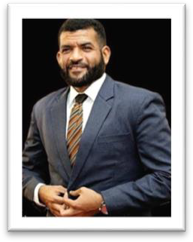

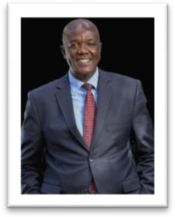

H.E Abdulswamad Shariff Nassir | H.E Fatuma Achani | H.E Gideon Maitha Mung’aro
Governor, Mombasa County | Governor, Kwale County | Governor, Kilifi County


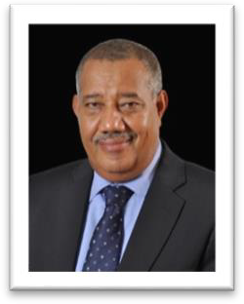
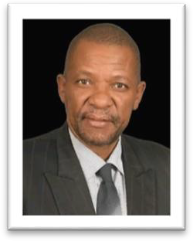

H.E Dhadho Godhana | H.E Issa Timamy | H.E Andrew Mwadime
Governor, Tana River County | Governor, Lamu County | Governor, Taita Taveta County

To support the bringing to life of the Jumuiya agenda, there is a Structured and inclusive Sector Consultative Platform run by the JKP Secretariat headed by the Chief Executive Officer Emmanuel K. Nzai. The Secretariat’s role is to have a broad view understanding of the region and creating the enabling environment that will ensure a platform for socioeconomic development of the region and thereby changing the story of the region. The Jumuiya Economic Development Secretariat (JKP Secretariat) boards of directors are the six county executive committee members in charge of finance and economic planning representing the 6 coastal counties. Key members of the secretariat are as follows:

The JKP Secretariat

The Jumuiya Economic Development Secretariat

The Jumuiya Economic Development Secretariat serves as the executive arm and operational engine of the Jumuiya ya Kaunti za Pwani (JKP). It is the professional body mandated to translate the strategic vision of the Council of Governors and the JKP Board into actionable programs, partnerships, and projects.

Mandate & Core Functions:
The Secretariat is specifically tasked with:

Coordinating Implementation: Driving the execution of the JKP 2030 Blueprint and the "Jumuiya 10" sectoral strategies across all six counties.

Resource Mobilization: Securing investment and forging strategic partnerships with development partners, the private sector, and academic institutions.

Stakeholder Engagement: Managing the inclusive sector consultative platforms that bring together government, academia, and industry for coherent planning.

Project Management: Providing technical oversight, monitoring, and evaluation for all JKP flagship initiatives and joint ventures.

Governance & Leadership:
The Secretariat operates under the strategic guidance of a Board of Directors composed of the County Executive Committee Members (CECMs) in charge of Finance and Economic Planning from each member county. Day-to-day leadership and management are vested in the Chief Executive Officer (CEO), supported by a team of sectoral experts, project managers, and finance and administration professionals.

Operational Model: The Triple Helix in Action
True to JKP's founding principle, the Secretariat operationalizes the Triple Helix Model of development. It acts as the central node that integrates:
- County Governments for policy alignment and public sector leadership.
- Academia (Pwani University, Technical University of Mombasa, Taita Taveta University) for research, innovation, and skills development.
- Private Sector for investment, market linkages, and job creation

This model ensures that regional development is innovative, evidence-based, and market-responsive, creating an enabling environment for sustainable socio-economic transformation across the Coastal region.

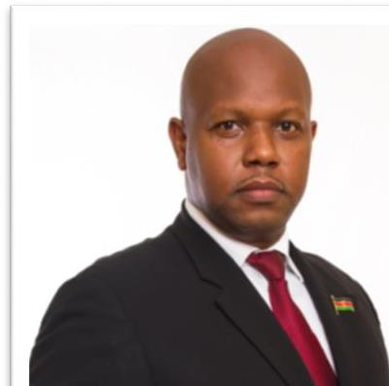
EMMANUEL K. NZAI CEO/SECRETARY JKP SECRETARIAT


DENNIS LEWA MUGANGA CHAIRMAN
JKP SECRETARIAT


ALLAN MZUNGU ATTORNEY
JKP SECRETARIAT

To contact us

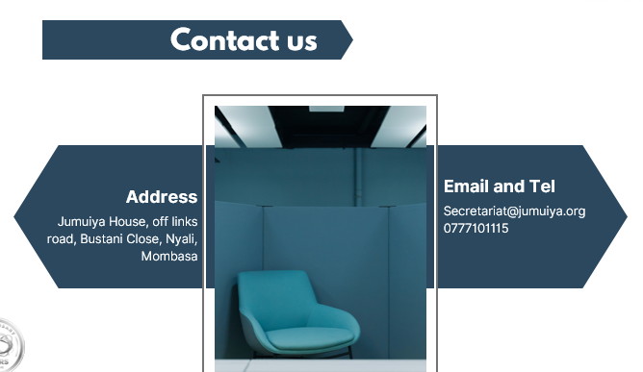

Jumuiya ya Kaunti za Pwani (JKP) Secretariat Bustani Close, off Links Road
Nyali
P.O. Box 90420 - 80100
Mombasa, Kenya
Tell: +254 777 101 115 | E: secretariat@jumuiya.org | W: www.jumuiya.org

